**Assignment 2: Case Development & Submission**

**Organization and Scenario Description:**

GoodHealth” is a healthcare organization aiming to serve the people with quality healthcare and is based in Colorado. The healthcare organization possesses a robust infrastructure, cutting-edge medical technology, and highly qualified medical professionals in all of its specialties, including cardiology, medicine, surgery, obstetrics, dentistry, psychiatry, and plastic surgery. The company serves a significant number of new patients each day as a result of its location in the bustling metropolis of Denver. The administration of "Good Health" believes that despite having sufficient cash, high-end equipment, and qualified medical professionals on staff, they are not providing the best possible treatment to their patients and that they are capable of doing better. As a result of this, the management has made the decision to implement a business intelligence approach in order to enhance the outcomes for patients, recognize trends, and devise more effective treatment programs.

There have been some situations involving patient stays at Good Health that have presented management with challenges. Because of the large number of new patients, Good Health Management has a restricted amount of space available. This is because of the strong demand for their services. Additionally, there is a risk of health complications if they are discharged too soon, and the operational effectiveness of the medical facility would suffer if they are detained for an extended period of time. All of these occurrences have led to difficulties in providing "patient stays" to those in good health.

This article examines the procedure of "business intelligence in improving patient outcomes," the significance of the procedure to the organization, the function of BI in the procedure, and the themes that are concerned with the procedure. This article also discusses the situations in which the data-information choice makes something intelligent, as well as the types of data that are involved, the sources of the data, and the "intelligent" elements of the situations.

**Process / Scenario Description:**

It is possible to see that hospitals in the United States are currently under both operational and financial difficulties in the present day. The razor-thin margins and limited premium bed capacity are two of the difficulties associated with this situation. Within the next five years, it is anticipated that there will be at least a 20% increase in the need for bed capacity. Increasing the number of available beds is one approach to this problem; however, doing so would be nearly impossible and would be prohibitively expensive. In this scenario, precisely determining and measuring the length of patient stays; in other words, by increasing the capacity of the service. "Good Health" utilizes patient tracking technologies in hospitals, such as Business Intelligence tools and algorithms, in order to enhance the flow of patients around the hospital, including in the emergency wards. This helps "Good Health" better serve its patients.

In the past, the length of a patient's stay was determined by a straightforward formula. This calculation consisted of either dividing the number of discharge days by the total number of discharges or dividing the number of inpatient days by the total number of admissions. However, this is not realistic because the severity of certain patients' conditions may need them to remain in the hospital for very extended periods of time while other patients may be discharged after only a couple of days. Therefore, even in this scenario, the LOS value is still erroneous, which results in excessive costs as well as inefficiencies in the management of vital-bad space as well as other medical expenses.

In subsequent phases, the medical experts began measuring Average Length Of Stays (ALOS) according to the medical disease, such as separating the patients who were admitted owing to pneumonia, cardiac heart failure, chronic kidney diseases, and other similar conditions. However, this still resulted in inaccurate ALOS because all of the physiological processes are connected to one another, and the severity of the patient's illnesses depends on their medical histories as well.

Tools that utilize machine learning and business intelligence both have a part to play in the process of overcoming these obstacles. In this scenario, patient records, EMRs, illness registries, and other relevant information are added to the database, and the AI mechanisms are trained using random forests and ensemble algorithms, some of which contain decision trees. This will assist in the generation of findings based on the medical histories, ailments that are being treated, and other considerations. In addition, business intelligence (BI) tools such as tableau and Power BI will be of assistance in visualizing the data for improved comprehension and the ability to make decisions based on accurate information. It is anticipated that the accuracy of LOS estimates will improve by as much as forty percent as a result of this.

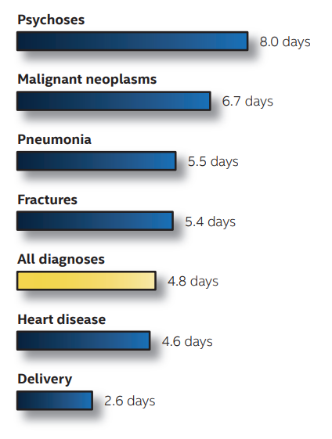

In addition, the Business Intelligence tools and the machine learning algorithms will function on structured as well as unstructured data, and they will predict the outcomes of patients who are likely to be discharged from the hospital within the next twenty-four hours. This will help in successfully allocating resources, specifically essential patient beds, as it will facilitate resource allocation.

The data-information-decision process plays an essential role as a critical component in the whole process of tracking patient stays. In the event that we need to calculate the average patient stay for a particular scenario, the data analytical tools and machine learning algorithms that work with the data are applied. These algorithms identify patterns within the data, such as the average patient stay for specific scenarios, and these patterns are displayed with the assistance of visualization tools such as Power BI, tableau, and so on. Throughout the entirety of this process, the management of "Good Health" will be kept updated in order to enable them to make strategic decisions. It is recommended that for this procedure, patient data be gathered from any and all sources available. In order to accomplish our goals, we require information from a variety of sources, including patient records, the patient's medical history, the patient's electronic health record (EHR), if the patient has one, the electronic medical record (EMR), data from the patient's wearables, disease registries, and administrative records.

**Data preparation for LOS prediction:**

It is common knowledge that the Length of Stay (LOS) has a significant role in the improvement of both medical and economical efficacy. If we are able to calculate the duration of stay, this will contribute to the reduction in the total number of days spent as an in-patient, as well as to an improvement in the overall treatment quality. In addition to this, there will be a decreased likelihood of infection. The use of ALOS will also contribute to an increase in hospitals' overall earnings. Determining the length of the patient's stay will also aid in successfully employing the hospital's resources. This is particularly essential because it is very difficult to get a bed these days, which results in high expenditures per bed (Editor, 2022).

Because the entire process of determining the length of a patient's stay is entirely based on data, there is a demand for a significant amount of inpatient information in addition to sickness registries. This is owing to the fact that there is a demand for both of these types of information. In addition to this, electronic medical records act as a storage facility for enormous volumes of data which include essential particulars. In addition, medical datasets will be of incredible assistance during the entirety of this process. In this particular setting, Good Health is able to make use of a database known as the Organization for Economic Co-Operation and Development (OECD) .

The information gathered from patients who were hospitalized to the critical care unit is stored in this database, which acts as a repository for the data (ICU). It comprises information on patient demographics, in-hospital transfers, laboratory test results, prescriptions, data from clinical information systems, billing diagnosis, and any other pertinent information. As a consequence of this, a OECD database, the electronic medical records of patients, measurements of vital signs, and a disease registry will all serve as the sources for this procedure. After the data have been gathered by the data warehouse, the machine learning prediction models are then applied to the information. In the majority of situations, the issue can be thought of as either a regression or a classification problem in order to create an accurate prediction of the ALOS. When the analysis is finished, the results are sent to the Business Intelligence tools so that the data may be viewed. This happens after the analysis has been completed.

**Why this process?**

It is aware that the Length of Stay (LOS) has a significant role in the improvement of both medical and economical efficacy. If we are able to calculate the duration of stay, this will contribute to the reduction in the total number of days spent as an in-patient, as well as to an improvement in the overall treatment quality. In addition to this, there will be a decreased likelihood of infection. The use of ALOS will also contribute to an increase in hospitals' overall earnings. Determining the length of the patient's stay will also aid in successfully employing the hospital's resources. This is particularly essential because it is very difficult to get a bed these days, which results in high expenditures per bed.

It is important to point out that there are a number of drawbacks to having a longer length of stay. We are able to determine how long it takes a patient to recover from a specific illness if we make use of methods that are associated with machine learning and business intelligence. This way, we are able to determine whether or not the patient is being kept in the hospital for an excessively long period of time despite the fact that he is healthy enough to be discharged. Because the longer a patient remains in the facility, the more clinical attention that needs to be spent on the patient by the personnel, attention that could be diverted somewhere else, possibly to persons who are at a greater danger. We are able to preserve the churning of the revenue model by reducing the length of stay, which means that we will not miss out on any opportunities for incremental revenue. This is important from a financial effect perspective. In addition, when we determine the length of a patient's stay, we search for patient beds, but we also look for resources such as maximum staff, X-ray systems, operation theaters, and other similar facilities.

**Process Map:**

The process map of determining and tracking a patient's stay will involve data-information-decision concept. The process starts with data collection from dependable sources. The data will be prepared from the sources as discussed above. The sources of data for determining patient stays are:

* Patient EMRs
* OECD Database
* Vital Records
* Disease Registry

The data that is gathered from these sources will be imported into a data warehouse in a variety of formats, including text, pdf, xls, and doc formats respectively. This is accomplished by first extracting data from various data sources, then processing the data such that it is of high quality, and finally loading the data into the data warehouse. This process of putting data into the warehouse will be repeated at predetermined intervals in order to ensure that the system is always up to date and in a position to provide precise results.

Additionally, a single platform for data retrieval is provided by the data warehouse, which makes the process much simpler. This is another advantage of the data warehouse. After that, the algorithms of machine learning are applied in such a way that they search for common occurrences as well as less common patterns, and they produce results that are tailored to the query.

In addition, the machine learning algorithms will be of assistance to the dashboards and the visualization tools by looking for them in particular parameters. Additionally, it assists the visualizations in choosing the appropriate combinations of data. Therefore, following the completion of the intelligent portion by machine learning, the business intelligence tools such as Tableau, Power BI, and others will project the learnings or insights received from the process of data analytics (Foshay & Kuziemsky, 2014).

Furthermore, they offer the possibility of human engagement, which means that they are able to accommodate minor alterations and even the introduction of data at unexpected moments. Because the BI tools help in providing the hospital management with a reliable projection model, which is a better way for the hospital management to easily understand large amounts of information, the visualization phase of the process will act as a knowledge base for the "Good Health" Hospital management. This is because the overall process will act as a knowledge base for the management of the hospital.

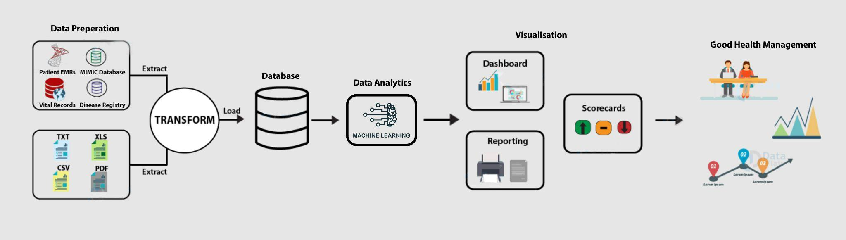

Process Map

**Comparative Outcomes Assessment:**

**Difference between Determining Patient Stay process without BI systems and with a BI:**

The preceding research makes it abundantly clear that business intelligence (BI) systems are an essential component of the patient determination process and that BI systems contribute to a significantly more effective method of determining the length of stay for a patient. It has been reported by Intel that the incorporation of BI systems into the process of determining patient stays will result in an increase in accuracy of up to forty percent. Because of this improvement in accuracy, the appointments for 15–20 percent of the patients will go more smoothly (“Length of Hospital Stay,” 2017).

In addition, because we are employing machine learning algorithms as an intelligent component, it is able to operate on massive amounts of data and recognize patterns, both of which are extremely challenging for people to do. In addition, business intelligence systems will produce one-of-a-kind outcomes depending on the queries, in contrast to the manual decision of patient stay, which will most often produce generic results. In addition, even if the Good Health managers choose to locate results based on the query, doing so would be a time-consuming process, in contrast to using the BI systems.

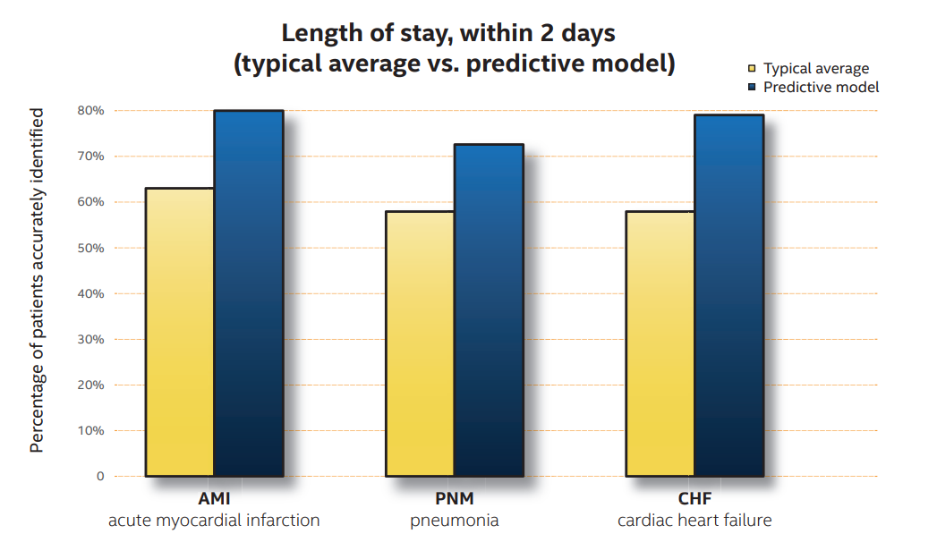

**Length Of Stay for Multisystem Inflammatory Syndrome associated in Covid-19:**

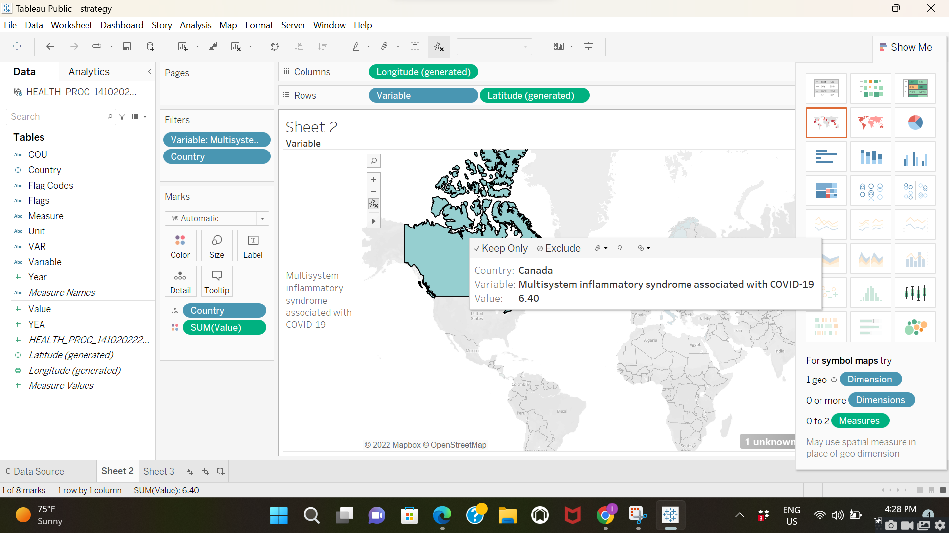

**Source: OECD Database**

According to this, the typical length of stay in Canada for a person infected with Covid-19 and suffering from a complication of Multisystem Inflammatory Syndrome is 6.40 days. Since we started using BI systems, it has become much simpler for us to seek for certain queries, even when those queries involve a number of different difficulties, because we now have trained machine learning algorithms working for them. One of the things that cannot be accomplished with manual labor is this.

In addition, we are able to obtain information regarding how long the patient is hospitalized for the various health problems that are categorized. For example, a patient who is suffering from infectious and parasitic disorders will need to remain in the facility for an average of 7.2 days. We might be able to determine an average ALOS via manual processing, but this won't work for categories that require accuracy. Because infectious diseases require cautious treatment, accurately forecasting their occurrence will allow the personnel to be prepared, which will also result in an increase in the level of safety.

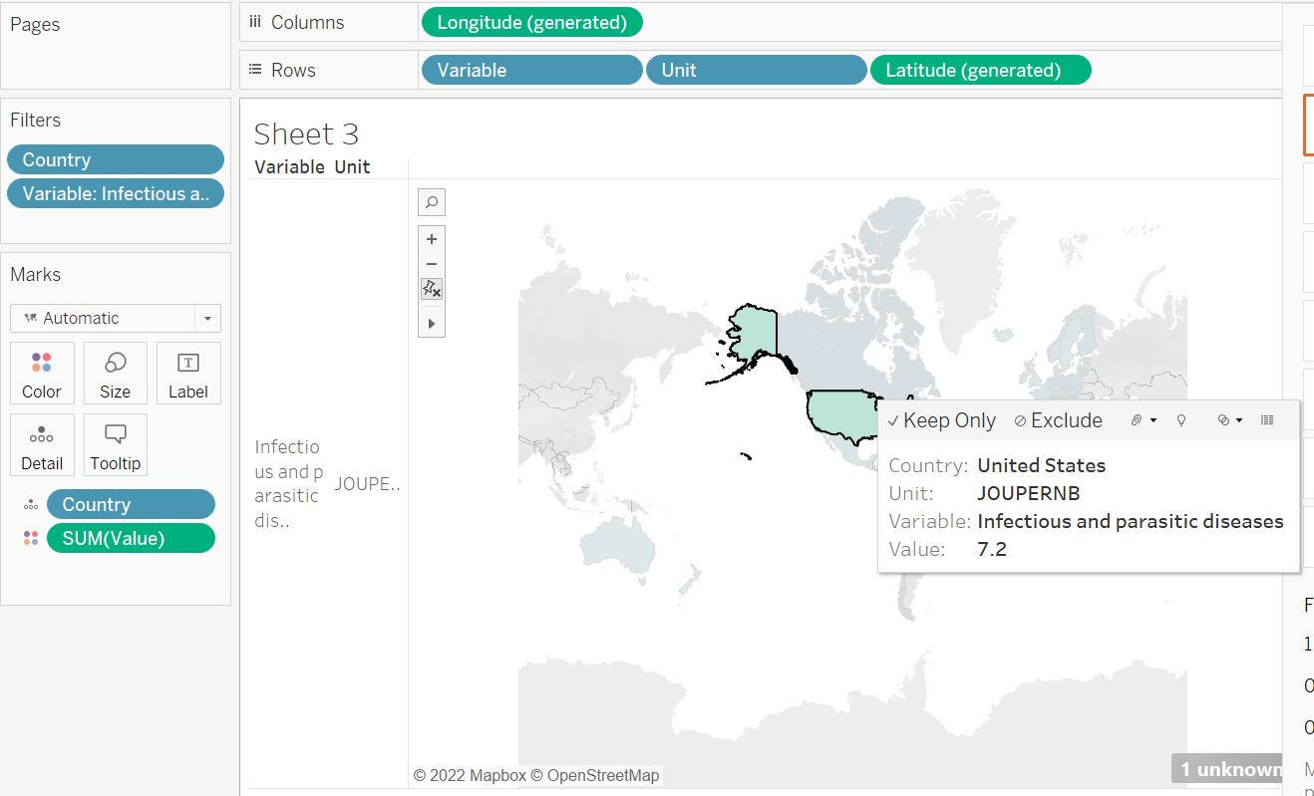

**Source: OECD Database**

Because the real-time data can change at any moment, the BI systems can take the updated data and process the changes very rapidly, which is something that cannot be done manually in this process. This is an additional advantage of using BI systems in this process. Take, for instance, the situation of a woman being pregnant. A pregnancy could have issues at any moment in time; when complications arise in real time, business intelligence tools will provide an estimated duration of stay for the patient, allowing medical professionals and other staff members to respond appropriately.

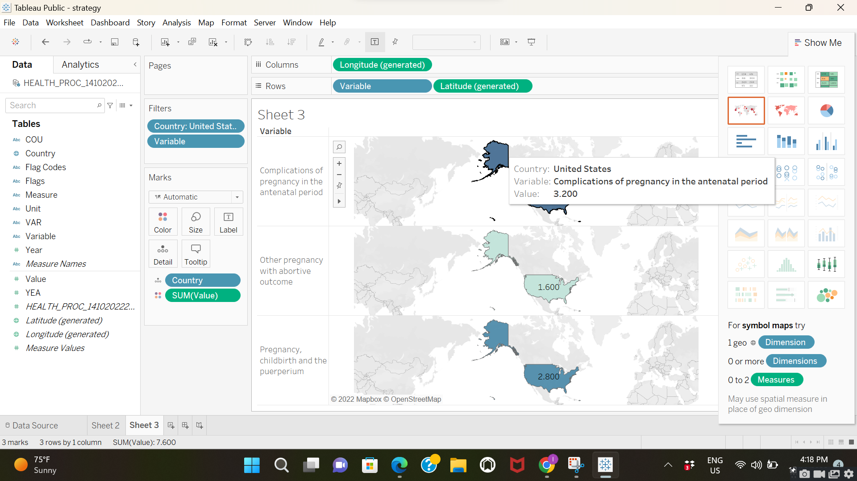

**Source: OECD Database**

Since length of stay is recognized as an important indicator in healthcare organizations, one can assert that business intelligence (BI) systems and technologies will have a significant and positive influence on this process. The incorporation of Business Intelligence and the tools that go along with it will have an effect on this process that is for the better, both monetarily and in terms of its operations and its strategic implications. The business intelligence (BI) systems will not only increase the profitability of the Good Health organization, but they will also have an effect on patient satisfaction, resource management, staff attention, reduced risk of infections, reduced costs, and a number of other factors. Because Business Intelligence may be dynamic and because it has the potential to act on real-time data, it has become far more effective than manual determination. This improvement can be measured in multiple folds.

**Conclusion:**

In the realm of healthcare, particularly among hospital administrations, the length of a patient's stay is a factor that is grossly undervalued. The length of a patient's stay is one such feature that can have a significant impact on a number of different aspects, as demonstrated in the analysis. This method, which was selected by Good Health, will go through a phase involving data, information, and decisions, and it will receive a dash of intelligence from the Business Intelligence Systems and technologies in order to provide superior care and make more educated choices.

**References**

Editor. (2022, May 27). *Length of Stay in Hospital: How to Predict the Duration of Inpatient Treatment*. AltexSoft. Retrieved October 14, 2022, from <https://www.altexsoft.com/blog/length-of-stay-hospital/>

Foshay, N., & Kuziemsky, C. (2014, February). Towards an implementation framework for business intelligence in healthcare. *International Journal of Information Management*, *34*(1), 20–27. <https://doi.org/10.1016/j.ijinfomgt.2013.09.003>

Length of hospital stay. (2017, November 15). *Health Care Use*. <https://doi.org/10.1787/8dda6b7a-en>

OECD (2022), "Data warehouse", *OECD.Stat* (database), <https://doi.org/10.1787/data-00900-en> (accessed on 14 October 2022).